Football Game Design Doc

# Card System

## Deck

The Deck will consist of 15 cards at a given time. Players can swap available cards in their deck between matches. The deck can consist of any number of a specific available card the player wants.

## Cards

A card consists of the below properties:

    class Card {

      constructor(name, type, rarity, text, ability) {

        this.name = name;

        this.type = type;

        this.rarity = rarity;

        this.text = text;

        this.ability = ability;

      }

Type = Attack / Movement / Skill. Attack is a pass or shot. Movement is moving a player around the pitch. Skill is a temporary boost to a player/team.

Rarity = common / uncommon / rare

Ability = effect of the card.

Example Card:

myCard = new Card(

        "Push Up",

        "Movement",

        "Common",

        "Move 1 player 1 position. Draw 1 card",

        { Move: 1, Draw: 1 }

      )

# The Match

## The Pitch

The pitch is a 3 x 6 grid. Each cell is considered a position. A position can contain 1 user player, 1 enemy player & the ball.

    const pitch = {

      top: { 1: "", 2: "", 3: "", 4: "", 5: "", 6: "" },

      mid: { 1: "", 2: "", 3: "", 4: "", 5: "", 6: "" },

      bottom: { 1: "", 2: "", 3: "", 4: "", 5: "", 6: "" },

    };

## Formation

Players will be set by the user to a set position on the pitch before the match. This formation will be set at the start of the match and after every goal.

      players: [

        { player: myPlayer, position: "mid:1" },

        { player: myPlayer, position: "top:2" },

        { player: myPlayer, position: "mid:3" },

        { player: myPlayer, position: "bottom:2" },

      ]

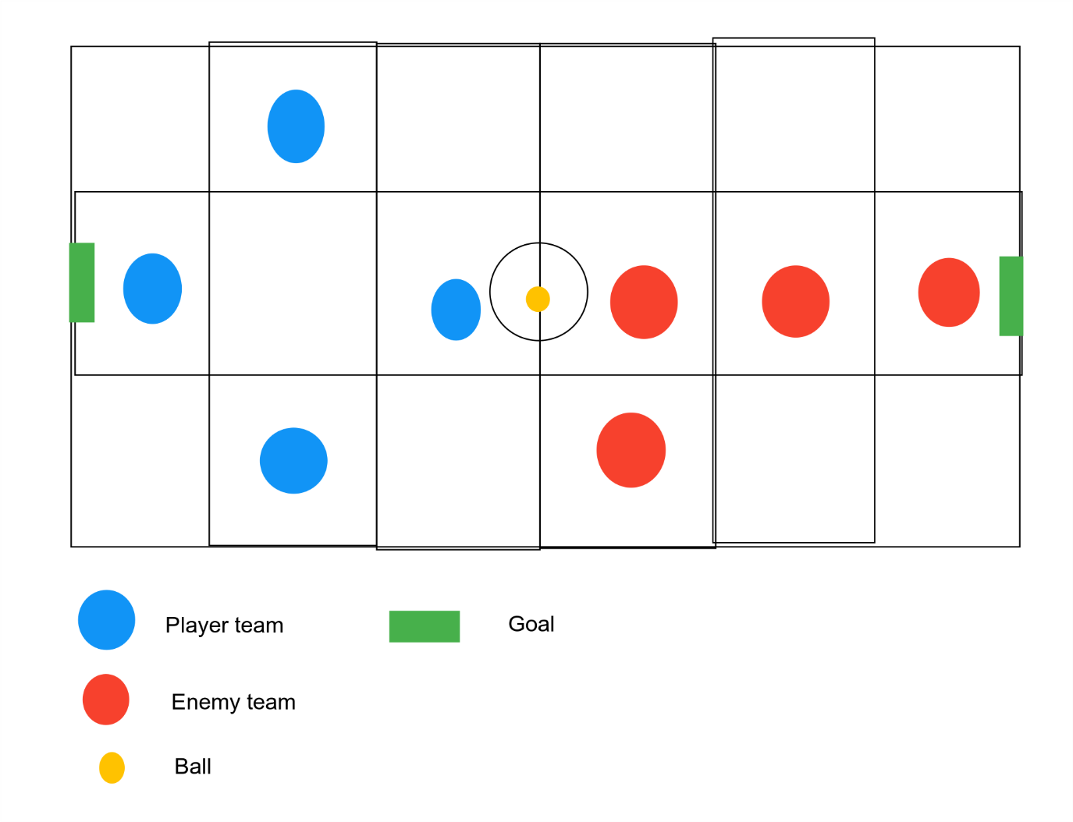

## Cell properties

The cell the player is in will affect the ability of the card played.

For example, if a user player attempts to shoot and an enemy player is in the same cell their chance for success is reduced. The below example shows how playing the shoot card in different positions made it less useful further away from the goal.

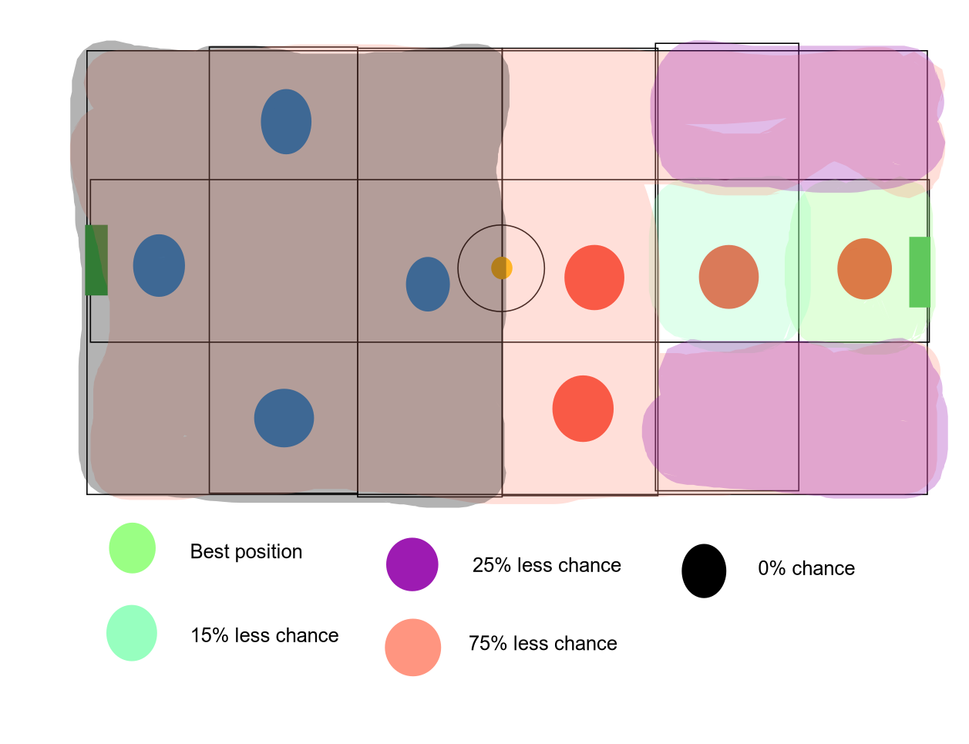

# Prototype

